TASK MANAGEMENT

Home Page:-Displaying all records from database

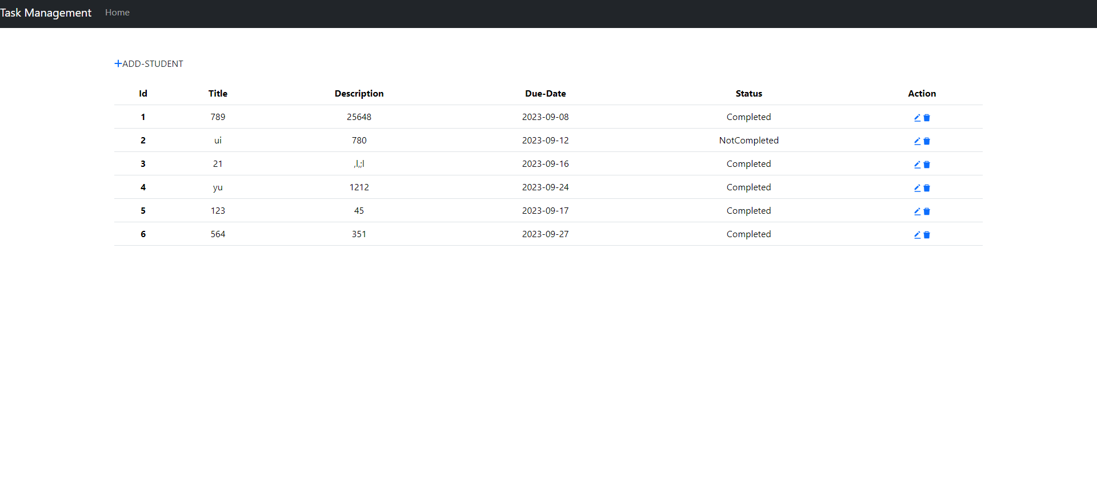

EditPage:-Updating records by fetching user id from url Params

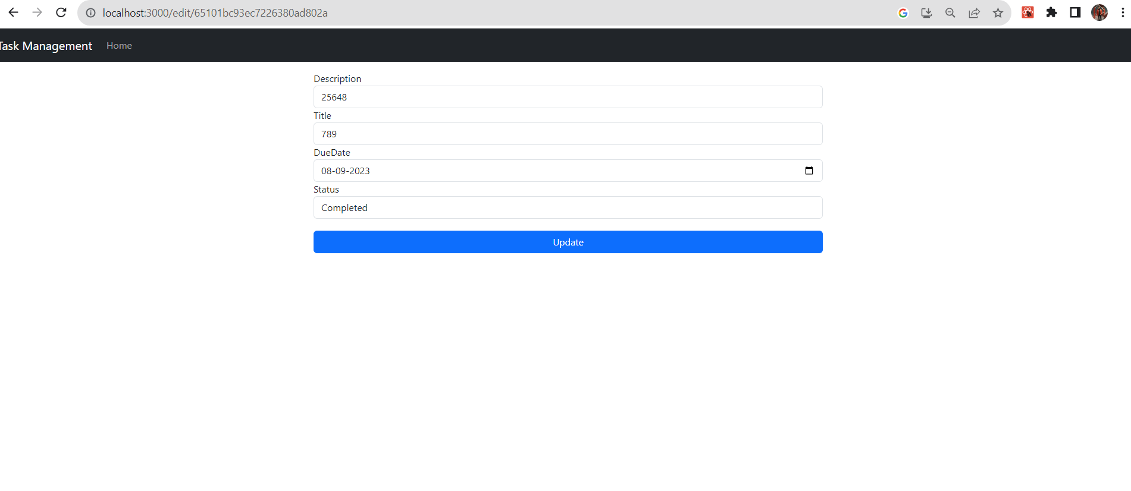

Add Task:- Add task page

